Contents

WISCONSIN BURNING PERMITS 1

Phone Numbers 1

Burn Permit Hot Links 1

Burning Permit Restrictions for TOWN OF NEW HOPE 2

Steps to safe burning 2

Legal materials -what you can and cannot burn 3

PRIOR TO BURNING 3

Know the risks 3

Understand the risks 3

Always consider alternatives to burning 3

Burning permit application 4

Before, During, After Burning 4

More information about burning permits 5

Campfires 5

Safety tips 5

Special permits 5

More information about burning permits 5

Burn location 5

Businesses or commercial entities 6

SUMMARY OF REGULATIONS FOR OPEN BURNING 6

# WISCONSIN BURNING PERMITS

**Please note that underlined phrases are hyperlinked**. To access that web page, right click anywhere on the phrase, then select *OPEN HYPERLINK* or hold the *shift key* and press the letter O.

Phone Numbers:

* Portage Co. Sheriff (non-emergency number) 715 346 1400
* Iola Fire Department (non-emergency number) 715 445 2515
* Wisconsin DNR (Burn Permits and Burning Information): 1-888-936-7463 or 1-888-936-7463

Burn Permit Hot Links:

["Can I burn" tool](https://www.surveymonkey.com/r/29W9VYS).

[*Burning restrictions map*](https://apps.dnr.wi.gov/wisburn/)

[Daily burning restrictions](https://apps.dnr.wi.gov/wisburn/#/BurnRestrictions)

[DNR dispatch office [PDF]](https://dnr.wisconsin.gov/sites/default/files/topic/ForestFire/Dispatchers.pdf)

[DNR Offices](https://dnr.wisconsin.gov/contact/OfficeLocations.html)

[Free permit online](https://apps.dnr.wi.gov/burnpermits/)

[Open Burning](https://dnr.wisconsin.gov/topic/OpenBurning)

[Safe Burning: Burn Responsibly or Don't Burn At All! [PDF]](https://embed.widencdn.net/pdf/download/widnr/gdjsvn9f5o/Responsible-Burning.pdf?u=lhzbht&showinbrowser=true)

[Wisconsin Burning Permits](https://dnr.wisconsin.gov/topic/forestfire/permits)

[Wisconsin Burning Permits](https://dnr.wisconsin.gov/topic/forestfire/permits)

**Each burning permit** is issued to a person, not a burn site. Once issued, that annual permit will cover that person anywhere in the state, provided local burning conditions and restriction requirements are met.

And remember to **have the permit with you** when you start a fire.

## Burning Permit Restrictions for TOWN OF NEW HOPE

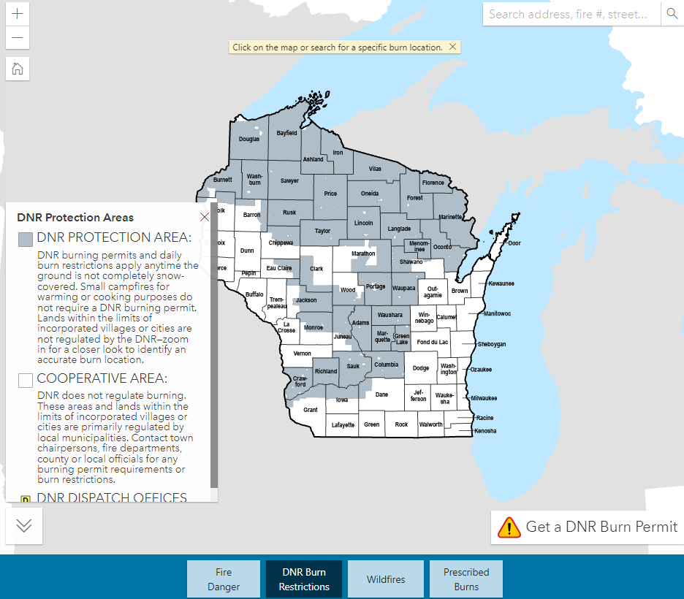A DNR annual burning permit is **required in the Town of NEW HOPE, as we are in a DNR PROTECTION AREA.** Be sure to read ***all*** of the information contained in the popup when you click on Portage Co (see Location below for more information). Notice that we are in a greyed area (key, left side), which means permits and daily restrictions apply anytime the ground is not completely snow-covered.

## Steps to safe burning

1. **Get a Wisconsin DNR** [**BURNING PERMIT**](https://dnr.wisconsin.gov/topic/forestfire/permits): Obtain a [free permit online](https://apps.dnr.wi.gov/burnpermits/) instantly with an email address. Or call the hotline 1-888-WIS-BURN (947-2876) from 7 a.m. to 10 p.m. daily to have a burning permit mailed to you. (Annual Jan-Dec, issued to an individual, not to a burn location)

*Permits are issued to the PERSON, not the burn site*. The annual permit applies anywhere in the state. The burning permit must be issued to the person lighting and attending fire; that person should have the permit on hand during the burn.

1. **Check before burning**: After 9 a.m. on the day you wish to burn, check the [Daily](https://apps.dnr.wi.gov/wisburn/" \l "/BurnRestrictions) [**[WISBURN Current Fire Situation](https://apps.dnr.wi.gov/wisburn/" \l "/BurnRestrictions)**](https://apps.dnr.wi.gov/wisburn/#/BurnRestrictions)[burning restrictions](https://apps.dnr.wi.gov/wisburn/" \l "/BurnRestrictions) and Fire Danger tabs (bottom of map) and select the county where you plan to burn. Fire conditions change quickly, so it's important to check each day you burn to find out if burning is allowed (with a permit), burning hours and any size limitations.
2. **Follow the rules**: Follow the daily burning restrictions and fire safety recommendations listed on the permit. Make sure to have all the necessary tools to keep your fire contained. Lastly, make sure your fire is completely out before leaving. Limited to 6 x 6 ft area.

* Read the article online for [Safe Burning: Burn Responsibly or Don't Burn At All! [PDF]](https://embed.widencdn.net/pdf/download/widnr/gdjsvn9f5o/Responsible-Burning.pdf?u=lhzbht&showinbrowser=true) Available in English, Hmong and Spanish.
* **Remember, the Town of New Hope is in a DNR Protection Zone**, so a **burning permit is required.**
* If your burn will produce significant smoke, **please notify your local sheriff’s office** and **the Iola Fire Dept.** to prevent unnecessary emergency responses.
  + **Iola Fire Dept non-emergency number: (715) 445 2515**
  + **Portage Co. Sheriff non-emergency number (715) 346 1400.**
* And it’s always a good idea to let your neighbors know before you start burning.

## Legal materials -what you can and cannot burn

Burning permits are issued to individuals wishing to burn small amounts of yard debris or clean wood from a single-family household on the property where it was generated either on the ground or in burn barrels. This includes prescribed or broadcast burns for land management purposes.

|  |  |  |
| --- | --- | --- |
| Allowed | NOT allowed | |
| * Brush * Leaves * Pine needles * Grass * Clean wood * Unrecyclable paper* * Unrecyclable cardboard*   *\*Recycling of clean paper and cardboard is required by law!* | * Garbage * Plastics * Shingles * Foam * Structures * Furniture * Wire * Metal | * Electronics * Vinyl Products * Rubber Products * Oil-based Products * Painted, stained or treated wood |

PRIOR TO BURNING, please check the **WISBURN Current Fire Situation website** <https://apps.dnr.wi.gov/wisburn/#/BurnRestrictions>. This site has four maps (Fire Danger, DNR Burn Restrictions, Wildfires, and Prescribed Burns). Click on the Fire Danger tab at the bottom to check for current conditions.

Burning permits are required by the Wisconsin DNR in many parts of the state to conduct legal and responsible burning in the outdoors, including areas under DNR Protected Zones (including New Hope). Burning permits are free and easy to obtain. They encourage the public to burn safely and are proven to be effective in protecting lives, property and natural resources from the damages of wildfires.

## Know the risks

Weather conditions and moisture content in vegetation play the biggest role in how wildfires start and spread. Therefore, the time of year and even the time-of-day influences how burning is regulated. Spring is Wisconsin's peak fire season and when most fire restrictions are in effect. This occurs shortly after the snow-cover disappears and prior to vegetation greening.

In addition, burning is typically restricted to late afternoon or evening hours to reduce the chances of a fire escaping. In the evening, winds are calmer, humidity rises and temperatures are cooler. Always keep an eye on the changing weather conditions and stay within the specified burn times and size limitations as indicated by the daily restrictions.

## Understand the risks

Permit holders must comply with all the conditions associated with the burning permit and take all reasonable precautions to prevent escape of the fire. The person responsible for lighting the fire is required to have a valid burning permit with them at all times while burning and must be available to present to law enforcement or firefighters if requested. If you fail to obtain a burning permit, do not comply with the daily fire restrictions or allow your fire to escape, you may be cited by law enforcement.

Remember, lighting any fire in the outdoors is risky. If you choose to burn and your fire escapes and starts a wildfire, you are liable for all suppression costs and potentially any damages associated with that fire. At any point if you are uncomfortable with your burn, do not hesitate to dial 911 immediately.

## Always consider alternatives to burning

* **Reuse:** Find someone else who can use it, have a yard sale or donate. Bring reusable shopping bags to the grocery store. Leave grass clippings on the lawn; they contain nutrients.
* **Recycle:** Separate newspaper, magazines, cardboard, paper, glass, plastic and aluminum, steel or tin cans.
* **Dispose:** Discard non-recyclable waste materials at a licensed landfill.
* **Compost:** Mulch or collect leaves and plant clippings for composting or move brush piles in the woods for wildlife habitat.
* **Chip:** Collect brush and clean wood to make mulch or decorative chips, or use as heating fuel in fireplaces.
* **Wait:** Avoid burning in the spring. The safest time to burn is when the ground is completely snow-covered. Throw a tarp over legal materials and wait until it snows.

## [Burning permit application](https://dnr.wisconsin.gov/topic/forestfire/permits)

Obtain a free DNR annual burning permit to burn [approved materials](http://dnr.wisconsin.gov/topic/ForestFire/permits.html#materials) in [DNR protection areas](http://dnr.wisconsin.gov/topic/ForestFire/permits.html#areas) by completing the self-issued burning permit application below.

Once the burning permit has been obtained (paper or electronic), remember to check the [fire restrictions](https://apps.dnr.wi.gov/wisburn/#/BurnRestrictions) in the appropriate county after 9:00 a.m. each day before burning. Required information: Name, Mailing address (not burn location), Phone, Email.

* **Prior to burning**, I will call the hotline or visit the website to check the daily burning restrictions 1-888-WIS-BURN (947-2876) or dnr.wisconsin.gov keyword "FIRE."
* **I will only** burn clean untreated wood, clean non-recyclable paper products and vegetation. I have considered other means of disposal such as composting or recycling.
* **I will not** burn garbage or anything that is recyclable. This includes, but is not limited to: plastic; shingles; wire; metal electronics; asphalt; painted or treated wood; rubber or oily substances; or structures of any kind (barns, sheds, homes, etc.)
* **I will** attend my burn at all times and make certain it is completely extinguished and cold to the touch before leaving.
* **I will** comply with local ordinances, which may be more restrictive than state law.
* **I am not** burning waste generated by a business or commercial entity.
* **SAFETY MESSAGE:** If my burn escapes my control, I will dial 911 immediately. Please note: forest fires can result in death or cause great bodily harm.
* By checking this box I hereby acknowledge all terms and conditions of this permit, that I am 18 years of age or older and that I have the physical and mental capacity to conduct any burning for which this annual burning permit is issued. (per Wis. Admin. Code ss. NR 30.03.(2)(d) and NR 30.04(2)(d)). I understand the permit is invalidated upon violation of any of its restrictions and non-compliance shall be considered a permit violation. This permit may be cancelled by the department when deemed necessary.
* An electronic OR printed copy of the burning permit is required, either will be accepted. If a valid email address is entered above, an electronic copy of the permit will be sent to that email address.
* Don't have an email address or printer? Call 1-888-WIS-BURN (947-2876) to have a permit mailed or visit a [DNR office](http://dnr.wisconsin.gov/contact/OfficeLocations.html) or an [Emergency Fire Warden](https://apps.dnr.wi.gov/forestryapps/emergencyfirewarden) to get a permit in person.

## Before, During, After Burning

|  |  |  |
| --- | --- | --- |
| **Before burning** | **During burning** | **After burning** |
| * Find [alternatives to burning](https://dnr.wisconsin.gov/topic/Recycling/) debris before deciding to burn. * Obtain proper burn permits and follow any restrictions. * Comply with local ordinances that may be more restrictive than state law. * Make certain you are only burning [legal materials](https://dnr.wisconsin.gov/topic/OpenBurning/BeforeYouBurn.html). * Keep an eye on the weather and avoid burning under windy conditions. * Make certain the area adjacent to the fire is free of all flammables. | * Have a water source and firefighting tools handy. * Keep the size of the fire small and manageable. * Maintain a mineral soil firebreak around the burn area. * Never leave your fire unattended. * If weather conditions change for the worst, put the fire out. * If your fire escapes, dial 911 immediately! | * Make sure the burn is completely out before leaving. * Use lots of water, drown, stir and repeat until cold. * Go back and check again later for any remaining smoke or embers. * Fun fact: use cold ashes from your burn as a bed for your garden. It makes a great fertilizer! |

## More information about burning permits

DNR burning permits are issued annually to a person, not to a specific address and are non-transferable. Your burning permit is assigned to you, as an individual and can be used anywhere in the state that a DNR burning permit is required as long as you have complied with local and state burning laws. Remember to check the [daily burning restrictions](https://apps.dnr.wi.gov/wisburn/#/BurnRestrictions) before burning.

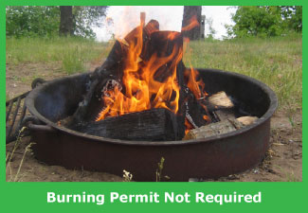Contact your local DNR office, fire department, town chairperson or local municipal official if you have any questions on the burning regulations where you plan to burn.

## Campfires

If you are burning in a campfire ring or fire pit with the intent to eliminate debris, a DNR burning permit is required. However, small fires for warming or cooking purposes do not require a DNR burning permit and are allowed anytime of the day, except during Emergency Burning Restrictions.

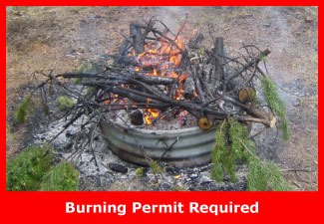Even campfires in a fire ring or fire pit can cause a wildfire! Be aware of the [daily fire danger](https://apps.dnr.wi.gov/wisburn/) before conducting any burn in the outdoors.

## Safety tips

Avoid burning in the spring! The safest time to burn is when the ground is completely snow-covered. Throw a tarp over legal materials and wait until snow accumulates and will remain on the ground for the duration of your burn.

Debris burning is the number one cause of wildfires in Wisconsin. Using fire as a method to dispose of vegetative yard waste isn't the only option. While debris burning is legal in most places, let's face the facts...it's unsafe, unhealthy and a nuisance. If you choose to burn, follow these simple guidelines to ensure you are burning safely.

## Special permits

Upon DNR inspection, special permits may be issued for burning outside the restricted burn times, land clearing and piles or prescribed burns exceeding the maximum size limit. Maximum pile sizes and acreages are limited by geographic area and indicated within the [daily burning restrictions](https://apps.dnr.wi.gov/wisburn/#/BurnRestrictions). Contact your local DNR Ranger Station or [DNR dispatch office [PDF]](https://dnr.wisconsin.gov/sites/default/files/topic/ForestFire/Dispatchers.pdf) for more information.

## More information about burning permits

DNR burning permits are issued annually to a person, not to a specific address and are non-transferable. Your burning permit is assigned to you, as an individual and can be used anywhere in the state that a DNR burning permit is required as long as you have complied with local and state burning laws. Remember to check the [daily burning restrictions](https://apps.dnr.wi.gov/wisburn/#/BurnRestrictions) before burning.

Contact your local DNR office, fire department, town chairperson or local municipal official if you have any questions on the burning regulations where you plan to burn.

## Burn location

Burning permits are issued to a PERSON, not a location. That free annual permit covers the person listed anywhere in the State, as long as conditions and restrictions permit the burn, and as long as the person listed is starting the fire, has the permit in hand during the burn, and attends the fire.

Burning permits are required in DNR forest fire protection areas (see map below) to conduct burning of [legal materials](https://dnr.wisconsin.gov/topic/OpenBurning/BeforeYouBurn.html) when the ground is not completely snow-covered.

DNR burning permits do not apply within incorporated cities and villages. These municipalities often can and do create their own burning permit requirements. In addition, some townships may choose to be much more restrictive than state law and may not allow burning at any time. Regardless of where you burn, it is up to you check with your local municipality for their regulations, even if you have obtained a DNR burning permit. Not sure if your burn location falls within DNR forest fire protection? For a more detailed look, zoom-in to your location on the [*burning restrictions map*](https://apps.dnr.wi.gov/wisburn/).

The DNR Forest Fire Protection Map below (left) shows areas and times where permits are required.

The WISBURN map on the right shows most of Portage Co. in the DNR Protection area, indicating that a burning permit is required.

*Not sure if your burn location falls within DNR forest fire protection? For a more detailed look, zoom-in to your location on the*[*burning restrictions map*](https://apps.dnr.wi.gov/wisburn/)*.* WISBURN map showing DNR Burn Restrictions (above), Fire Danger, Wildfires, and Prescribed Burns.<https://apps.dnr.wi.gov/wisburn/#/BurnRestrictions> (right)

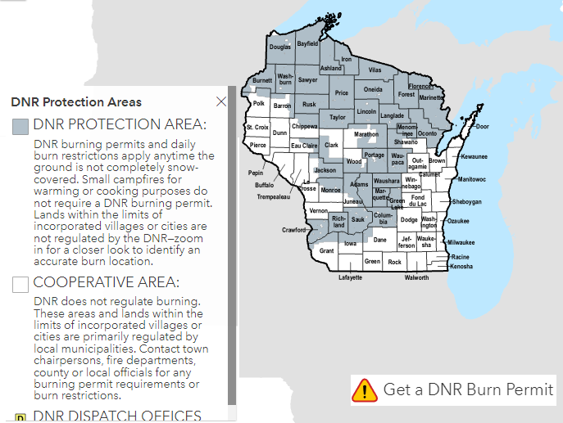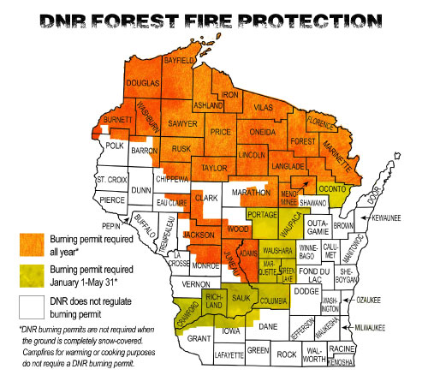

Note that you need to read the entire key on the left of the WISBURN map on the right, and scroll down on the popup that appears when you click on Portage Co. to see the entire message on the DNR Burn Restrictions Map: **The first portion reads** *“A DNR annual burning permit is not required in a few parts of Portage County from June 1st to December 31st except when emergency burning restrictions are in effect. Therefore, burning is allowed any time today. Please check the daily fire danger and adjust your burn plans accordingly. If your burn will produce significant smoke, please notify your local sheriff’s office to prevent unnecessary emergency responses.”*

**Scroll down for the second portion:** “***! Parts of this county may not be regulated by the DNR ! (The greyed areas on the map)*** *This county may contain both DNR Protection Areas and lands where the DNR does not regulate outdoor burning. Lands outside of DNR Protection and within the limits of incorporated villages or cities may create their own burning ordinances, as well as set their own burn restrictions. In addition, although the mapping data and systems used by the department have been produced from sources believed to be reliable, no guarantee is made regarding the accuracy of the user's selected location. It is your responsibility to know where you are burning. If you are not sure where your burn location falls, contact the local DNR office, fire department, town chairperson or local municipal official for clarification prior to any burning.*

*In the far-right lower corner, you will see a reminder: GET A DNR BURN PERMIT.*

## Businesses or commercial entities

Businesses or commercial entities burning waste materials, including waste generated off-site by individuals, is not valid under this annual permit but may be eligible for a solid waste [wood burning facility license](https://dnr.wisconsin.gov/topic/OpenBurning/Summary.html). Contact the DNR solid waste specialist for your area prior to any burning.

## SUMMARY OF REGULATIONS FOR OPEN BURNING

Several DNR programs regulate open burning for the purposes of air quality maintenance, proper management of solid wastes and wildfire prevention. Below is a brief summary of the DNR programs that regulate open burning and a list of relevant open burning laws and regulations. To learn more about regulations affecting the open burning of specific materials, visit [Know before you burn](https://dnr.wisconsin.gov/topic/OpenBurning/BeforeYouBurn.html) or use the ["Can I burn" tool](https://www.surveymonkey.com/r/29W9VYS).

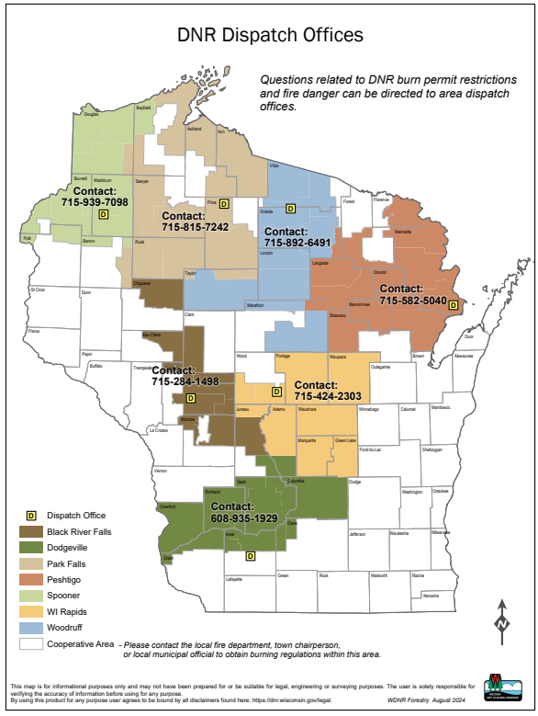

1. **Air Management**

The DNR's air quality rules generally prohibit open burning, but list several specific exceptions in ch. NR 429.04, Wis. Adm. Code. Any open burning that is allowed must be done under favorable wind and weather conditions, and conform to local ordinances and state fire protection regulations.

1. **Waste & Materials Management**

Commercial, industrial and municipal facilities are prohibited by the 1990 Recycling Act from landfilling or burning yard wastes without energy recovery, or burning many recyclable materials such as paper and cardboard. However, solid waste management rules allow the burning of certain woody material at specially licensed woodburning facilities that meet criteria in s. NR 502.11, Wis. Adm. Code. This same section of code (Section 502.11) also provides for open burning under specific circumstances without a woodburning facility license.

1. **Forestry**

The DNR's burning permit rules apply to open burning in certain areas of the state where DNR has fire protection responsibility. Chapter NR 30, Wis. Adm. Code, identifies the "intensive" and "extensive" fire control areas that require permits before open burning can occur.

Links to **Additional Resources:**

[DNR Offices](https://dnr.wisconsin.gov/contact/OfficeLocations.html)

[**DNR Programs**](javascript:void(null);)

[Burning Restrictions and Fire Danger](https://apps.dnr.wi.gov/wisburn/) [**Burning Permits**](https://dnr.wisconsin.gov/topic/forestfire/permits) [Prescribed Fire](https://dnr.wisconsin.gov/topic/forestfire/prescribedfire)

[Emergency Fire Wardens](https://apps.dnr.wi.gov/forestryapps/emergencyfirewarden)

[**Fire Management**](https://dnr.wisconsin.gov/topic/forestfire)

[**Forest Fire**](https://dnr.wisconsin.gov/topic/forestfire/fireManagementDashboards) (Current and Historic Wildfires and Prescribed Fires)

[**Laws and Regulations**](javascript:void(null);)

[Legal and Illegal Burning](https://dnr.wisconsin.gov/topic/OpenBurning/BeforeYouBurn.html)

[**Model Burning Ordinance**](https://widnr.widen.net/view/pdf/gitihsrtmg/AM356.pdf?t.download=true)

[Preparing Your Property](https://dnr.wisconsin.gov/topic/forestfire/preparing)

[Recycling and Composting](https://dnr.wisconsin.gov/topic/recycling)

**For more information, contact**

* [**Catherine Koele**](https://apps.dnr.wi.gov/staffdir/ContactSearchResultsExt.aspx?cno=26649&cSrc=EMPLOYEE), Wildfire Prevention Specialist <tel:+1-608-219-9075>