**town of new hope AND portage county Recycling NEWS:**

**Do I have to recycle?** *Yes! State Law and Portage County Ordinance mandate the recycling of tin & aluminum cans, glass bottles & jars, plastic #1 & #2 containers, cardboard, newspaper, magazines, office paper, junk mail, waste oil, oil filters, vehicle batteries, tires, appliances, yard waste, and electronics.*

* Recycling **SAVES MONEY**! Recycling reduces the amount of garbage landfilled, decreasing the amount of tax dollars your Township needs to pay for disposal!
* Recycling **saves natural resources**! On average, for every 120 pounds of paper recycled, we save one tree!
* Recycling **saves energy!** Did you know that recycling one plastic bottle conserves enough energy to light a 60W bulb for up to 6 hours!
* Recycling is an easy way to **do something positive** for the environment, the community, and the world.

**What can I recycle*?*** *Here in New Hope****,*** *Harter’s uses a ‘single-stream’ system that allows you to put everything into one bin (no need to separate, and please, don’t leave your recycling items in plastic bags). Harter’s recycles, tin and aluminum cans, #1 & 2 plastics, glass bottles and jars*, and paper*.*

**With all recycling:** *Please empty containers, rinse. Discard plastic caps or lids.*

*Discard paper soiled with food waste or grease (like used pizza trays, burger wrappers, etc.)*

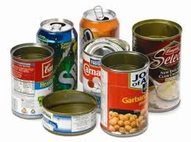

***Tin & aluminum cans****: Please discard unattached lids.*

* *Aluminum cans are recycled back into more aluminum cans, resulting in a 95% savings in energy.*
* 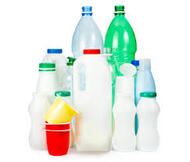*Tin cans are used in making various car parts, custom metal castings, etc.*

***Plastic #1 & #2 bottles:*** *Please discard lids and caps. No plastic bags or plastic wrap (return to retail).*

* *Plastic #1 bottles are used to make carpeting, clothing, and more plastic bottles.*
* 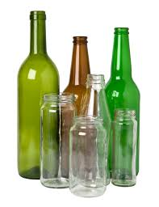*Plastic #2 bottles are made into plastic lumber, recycling bins, and more plastic bottles.*

***Glass bottles and jars (food & beverage ONLY)****: All colors can be mixed together!*

*Please discard lids and caps. And remember:* ***no cups, drinking glasses, ceramics, window glass, vases, cookware, light bulbs, or candleholders/jars.*** *These should be put in the trash, wrapped if necessary to prevent cuts.*

* *Drinking glasses, window glass, ceramics, light bulbs, etc. have a makeup different from bottle and jar container glass. Food and beverage container glass all melt at the same temperature, whereas other glass does not.*
* 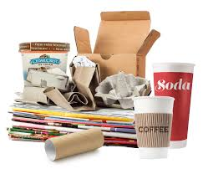*Glass bottles & jars are made into more bottles and jars, fiberglass insulation, and aggregate for road base.*

***Newspaper, office paper, magazines, shredded paper, junk mail, catalogues, egg cartons, cardboard, and container board.*** *Please flatten cardboard boxes.**Discard any paper soiled with food (like pizza trays, burger wrappers, etc.)*

* *Paper and cardboard are made into more paper and card-board, significantly reducing the number of trees needed.*

**Frequently Asked Questions . . .**

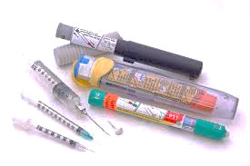**How should I dispose of SHARPS (needles)?**

*Needles used to administer human and animal medicines* ***cannot be thrown in the trash or set out with recyclables****.*

* *Sharps from residential homes may be brought to one of the following locations for proper disposal:*

1. Metro Market Pharmacies (Stevens Point and Plover)
2. Hometown Pharmacies (Stevens Point and Plover)
3. Festival Foods Pharmacy (Stevens Point)
4. Portage County Solid Waste (Plover)

**How should I dispose of unwanted or old medications?** *Medications should* ***NEVER be flushed*** *down the drain due to contamination of ground and surface waters. Also due to potential for drug abuse and identity theft, meds should not be disposed of in the trash.*

* 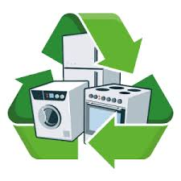*Properly dispose of unwanted medication at the Plover or Stevens Point Police Station during normal business hours. Put medication in a sealed bag.*

**What do I do with an old appliance, computer or TV?** *Effective September 1, 2010, computers, TVs, and other electronics can no longer be disposed of in the trash.*

Watch for County-wide recycling events, posted on the Portage County Solid Waste website or your local town recycling event.

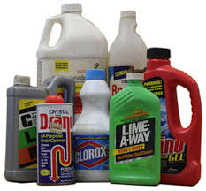**Household Hazardous Waste**: Rid your home of hazardous materials like pesticides, herbicides, cleaners, paints, chemicals, gas, and aerosols. The Hazardous Waste Collection Program runs from March through November by appointment only (call 715-346-1931 – fees apply).

**What about Latex Paint?** Latex paint is not hazardous, but it must be solid before throwing away. Fill a half-empty can with OilDry or cat litter. Mix completely and leave lid off (should be the consistency of lumpy oatmeal). When the paint is dry (2-4 days), leave the lid off, and throw it in your trash.

* 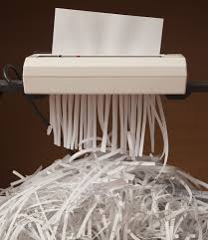You can also dispose of latex paint at the Portage County Solid Waste Facility for a small fee per pound. Call 715-346-1931.

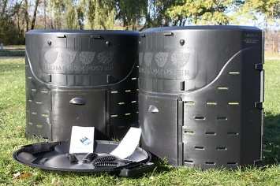**Document Shredding**: Secure document shredding is available at the Portage County Solid Waste Facility (limit three bank-sized boxes per visit, small fee per box). Place in paper bag, secure and label, put into recycling bin.

**Yard Waste:**

**Yard waste such as leaves, grass clippings, garden debris, and brush six inches in diameter or smaller (which includes Christmas trees)** **are banned from Wisconsin landfills.** These items are not accepted at the Portage County Solid Waste Facility. Compost onsite or contact your municipality for options. Yard waste is **Not** picked up by Harter’s.

Consider composting.

[Recycling Connections](https://www.recyclingconnections.org/product-page/the-home-composter-1) sells backyard compost bins, contact them for pricing and availability. 715.343.0722

[Bucket Ruckus](https://www.bucketruckus.cc/) collects food waste and garden debris from residents in the greater Stevens Point area. Contact them directly for more information. [kelly@bucketruckus.cc](mailto:kelly@bucketruckus.cc)

[Busy Bee Compost](https://www.busybeecompost.com/information) in Mosinee accepts yard waste from residents. Contact them for drop-off location and hours. [https://www.busybeecompost.com/information 920-918-9539](https://www.busybeecompost.com/information%20%20920-918-9539) [mgamoke@gmail.com](mailto:mgamoke@gmail.com)

What do I do with… (<https://www.co.portage.wi.gov/647/What-Do-I-Do-With)>...

See the **Portage County WI Solid Waste** site (right click the link above, then click *Open Hyperlink*).

[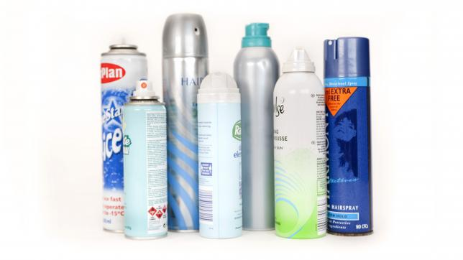](https://www.co.portage.wi.gov/698/Aerosol-Cans)**Aerosol Cans**

Full or partially full aerosol cans are not curbside recyclable and may be recycled through the Hazardous Waste Program by calling (715) 343-6297.

Empty aerosol cans (press spray button to be sure it’s empty) can be put into Harter’s recycling bin.

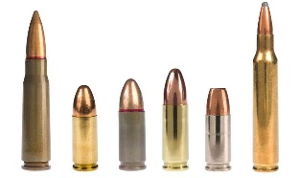**Ammunition**

Used ammunition is not recyclable. Throw it in the trash.

Unused ammunition can be brought to the following facilities.

* Stevens Point Police Department
* Plover Police Department
  + - Izaak Walton League of America - Bill Cook Chapter.
      * Email John Dolan, [jd1bowman@sbcglobal.net](mailto:jd1bowman@sbcglobal.net)
    - 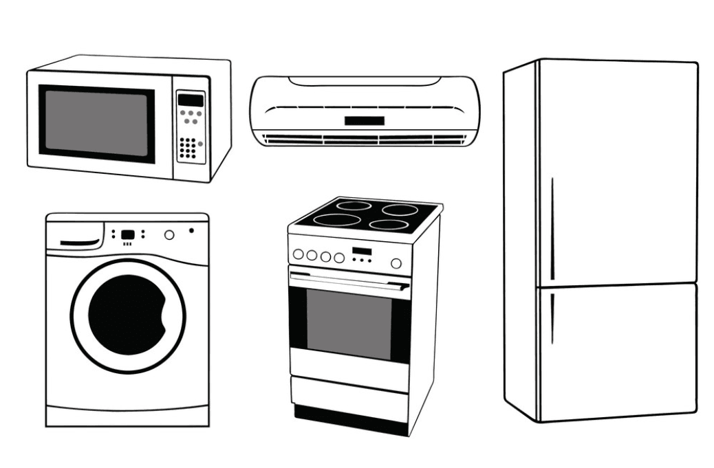Heart of Wisconsin Sportsman Club.
      * Call (715) 325-5163 Thursday mornings or Sunday afternoons

**Appliances**

Appliances can be taken to the Portage County Solid Waste Facility for proper disposal. Fees do apply, visit the [Solid Waste and Recycling Disposal Fees page](https://www.co.portage.wi.gov/617/Solid-Waste-and-Recycling-Disposal-Fees) for up-to-date prices. Scrap metal facilities may accept some of them as

well.

**Examples of accepted items include:**

* Carpet & vacuum cleaners
* Dehumidifiers & humidifiers
* Dishwasher
* Dryer
* Freezer
* Furnace
* Microwave
* Refrigerator
* Stove
* Washing machine
* Water cooler
* Water heater

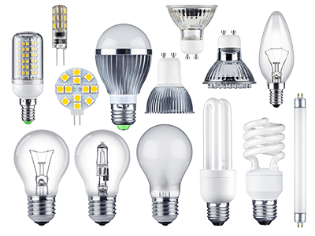**Bulbs and Ballasts**

**Do not put them in your curbside recycling bin**!

Broken LED or incandescent bulbs should be wrapped in paper, sealed and placed in trash. Portage County Solid Waste Department accepts all types of bulbs/lamps for recycling year-round. Fees do apply: Compact Fluorescent Lights (CFLs), Fluorescent Tubes (all sizes), Halogen bulbs, HID bulbs, Incandescent bulbs, LEDs, Sodium bulbs, Miscellaneous bulbs.

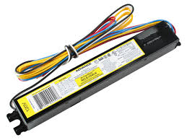NEON signs must be taken to Rapids Signs for proper disposal.

**Ballasts** from 1979 or older contain PCBs and need to be properly recycled. The Transfer Facility accepts electronic, PCB and non-PCB ballasts for a fee. Some scrap metal facilities will accept non-PCB ballasts at no charge.



**Carpet**

Carpet is considered regular garbage as long as it fits your trash bin.

* Visit the [Solid Waste and Recycling Disposal Fees page](https://wi-portagecounty.civicplus.com/617/Solid-Waste-and-Recycling-Disposal-Fees) for up-to-date pricing for larger pieces.
* [Carpet Plus](https://carpetspluswi.com/about/locations/plover-wi/) in Plover recycles certain types of carpet and carpet pad. Contact them for details.
* **Holiday Lights**
* Holiday lights can be thrown in the trash or brought the Portage County Solid Waste Department for recycling at no charge. Do NOT throw holiday lights in your recycling bin. Bulbs do not need to be removed from the stands of lights prior to recycling them.

**Electronics**

Residents can recycle banned and non-banned electronics at the portage County Solid Waste Department. Fees do apply. Visit the [Solid Waste and Recycling Disposal Fees page](https://www.co.portage.wi.gov/617/Solid-Waste-and-Recycling-Disposal-Fees) for up-to-date prices. Portage County Solid Waste is a registered E-Cycle Wisconsin electronics collector. Businesses need to contract directly with a recycler.

**The following items are banned from Wisconsin Landfills** and can be brought to the Solid Waste Department for recycling.

* Computer monitors
* Computers, laptops, tablets, netbooks, e-readers
* Computer accessories (keyboards, mice, speakers, external hard drives and flash drives)
* Televisions - all kinds
* video game consoles (i.e. X-box, Wii)
* video game system components and portable hand-held video game devices operated by a battery
* Cameras and recorders with screens
* DVD and VCR players/recorders
* Printers, scanners, fax machines
* Cell phones
* Best Buy and Staples accept certain electronics as well. Contact them directly for information on acceptable items and fees.
* Items such as microwaves, vacuum cleaners, humidifiers, and toasters are considered small appliances and are recycled as such.

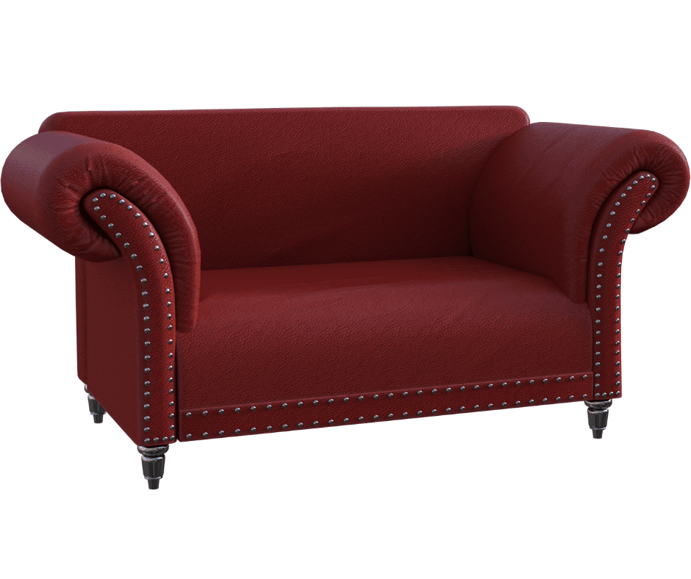**Furniture**

We encourage you to find new homes for items that are in good condition. However, if that's not possible furniture is considered regular garbage. Harter’s will pick up large pieces for a fee if prearranged (call Harter’s Disposal 715-446-5400 or 888-804-8556) Visit the Portage [Solid Waste and Recycling Disposal Fees page](https://wi-portagecounty.civicplus.com/617/Solid-Waste-and-Recycling-Disposal-Fees) for up-to-date prices for the following:

* Couches
  + Tables
* Chairs
* Dressers
* Recliners
* 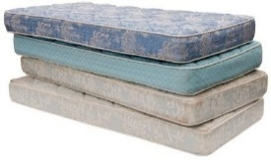Wooden framed beds (metal ones are recycled with scrap metal at no charge)
* Mattresses and Box Springs can be taken to the Portage County Solid Waste Facility

for disposal. Fees do apply.

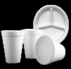

**Styrofoam**

Styrofoam is NOT recyclable in your curbside bin. Throw it in the trash.

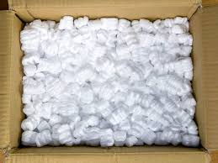The following facilities accept **clean** and **dry** Styrofoam for drop-off recycling.

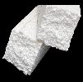[**Styrene Products, Inc.**](https://www.styreneproducts.com/contactus) 5320 Fuller Street. Schofield, WI 54729

* Only accepts white expanded polystyrene (EPS) foam. A.K.A beaded packaging Styrofoam, no plates or cups.

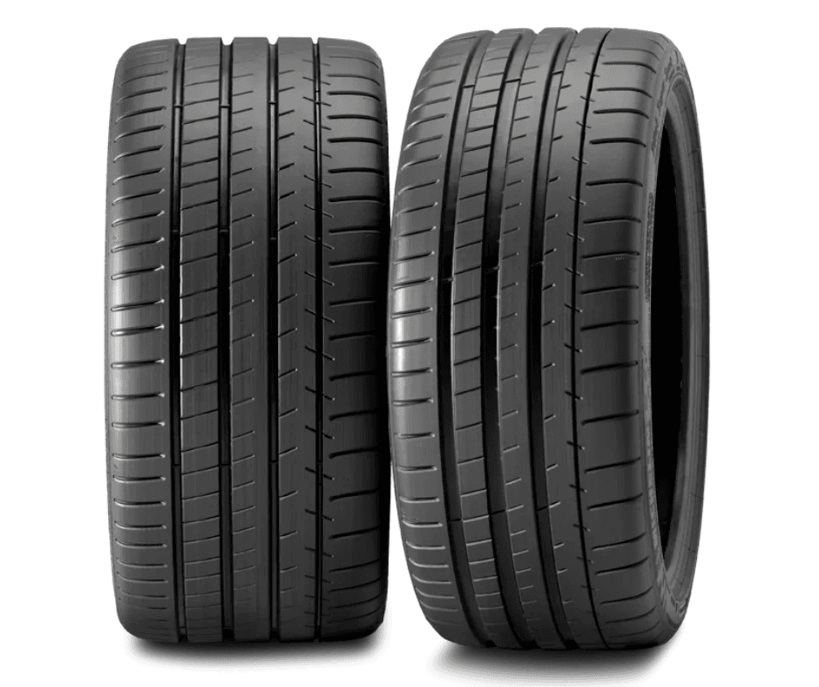[**Outagamie Recycling & Solid Waste**](https://www.recyclemoreoutagamie.org/contact-us/) 1919 Holland Road (Gate #3). Appleton, WI 54911

* Accepts all types of Styrofoam.

**Tires**

Passenger car and truck tires are accepted for recycling at the Portage County Solid Waste Department, with or without rims. Fees do apply. Visit the [Solid Waste and Recycling Disposal Fees page](https://www.co.portage.wi.gov/617/Solid-Waste-and-Recycling-Disposal-Fees) for up-to-date prices. There is no bulk rate. For large quantities of tires, it's recommend to go straight to Liberty Tire in Auburndale.

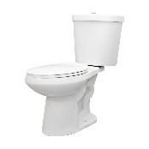Tires are also accepted at the **New Hope Recycling Event** in fall for a minimal fee.

**Toilets**

Toilets and other porcelain items like sinks and bathtubs, are considered regular garbage, but will not be picked up by Harter’s. Visit the [Solid Waste and Recycling Disposal Fees page](https://www.co.portage.wi.gov/617/Solid-Waste-and-Recycling-Disposal-Fees) for up-to-date prices.